**Experiment No. 2**

Aim: To implement Dimension and Fact table of Electronic Sales.

Requirement: Windows/Linux/Mac OS, MYSQL/Oracle SQL database app.

Theory:

Dimension Table:

A Dimension Table is present in the star or snowflake schema. Dimension tables’ help to describe dimensions i.e. dimension values, attributes and keys. It is generally small in size. Size can range from several to thousand rows. It describes the objects present in the fact table. Dimension Table refers to the collection or group of information related to any measurable event. They form a core for dimensional modelling. It contains a column that can be considered as a primary key column which helps to uniquely identify every dimension row or record. It is being joined with the fact tables through this key. When it is created a key called surrogate key that is system generated is used to uniquely identify the rows in the dimension.

Fact Table:

A fact table or a fact entity is a table or entity in a star or snowflake schema that stores measures that measure the business, such as sales, cost of goods, or profit.

Fact tables and entities aggregate measures, or the numerical data of a business. To measure data in a fact table or entity, all of the measures in a fact table or entity must be of the same grain.

To obtain the most useful data in a fact table or entity, you should use measures that are both numeric and additive. Using these measures guarantees that data can be retrieved and aggregated, so that the business can make use of the wealth of business data in the database.

Fact tables and entities also contain foreign keys to the dimension tables. These foreign keys relate each row of data in the fact table to its corresponding dimensions and levels.

**Product Dimension Table**:

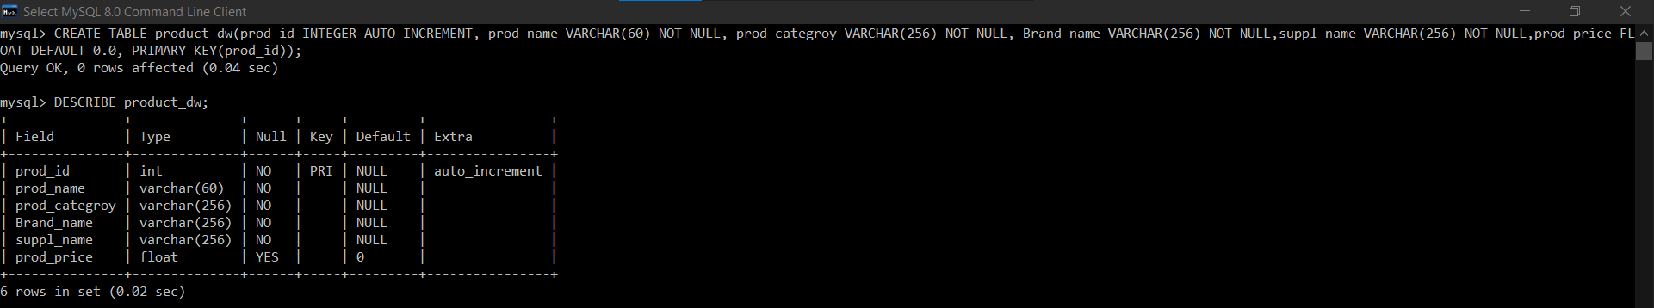

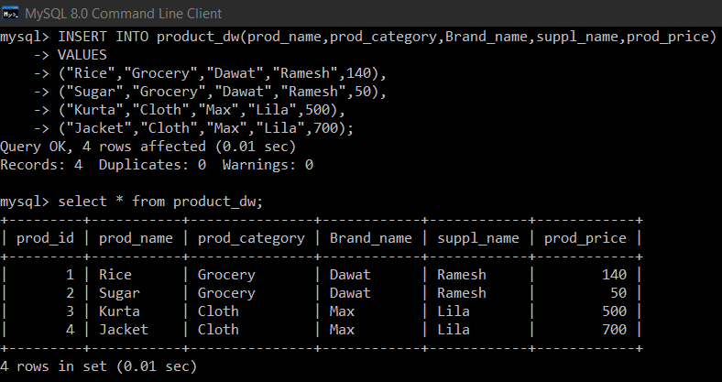

**Location Dimension Table**:

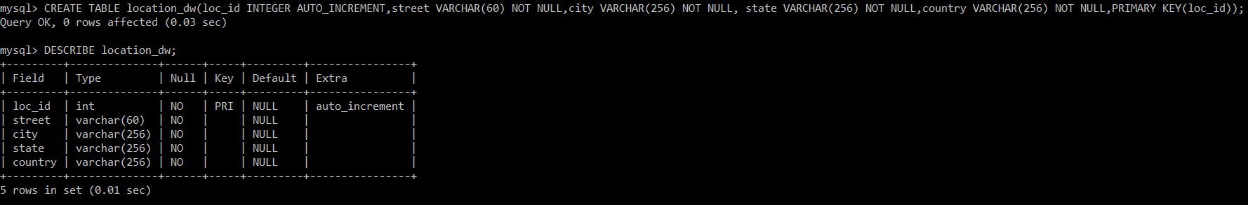

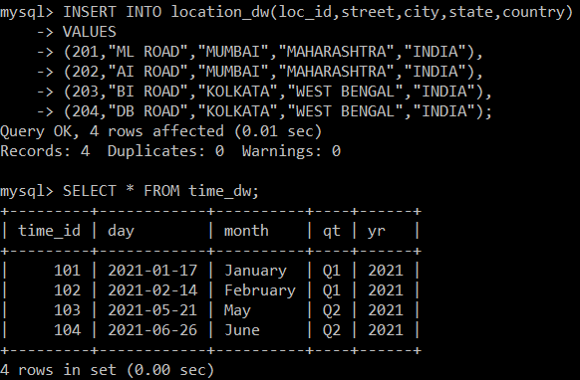

**Time Dimension Table**:

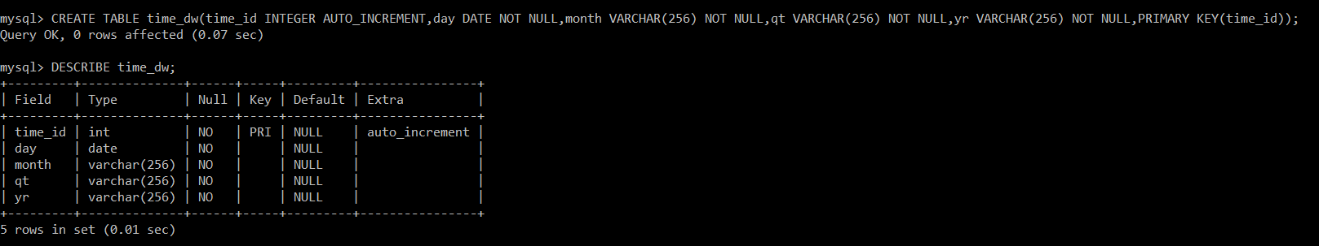

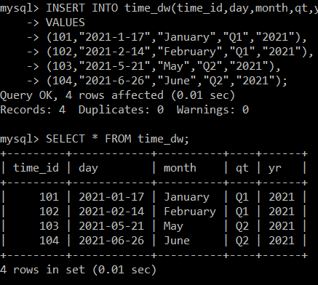

**Sales Fact Table**:

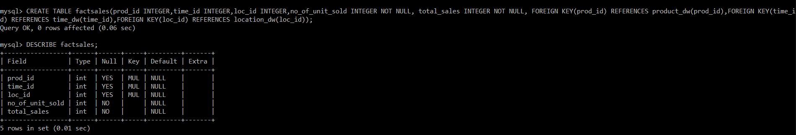

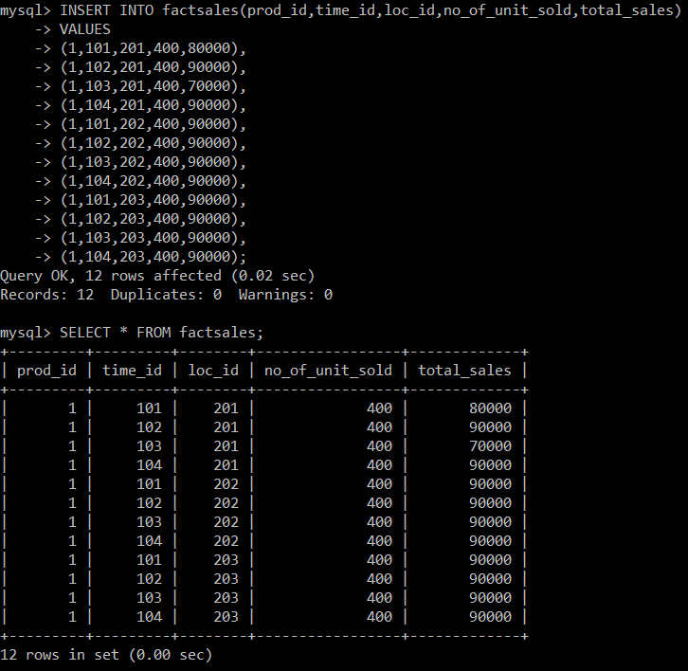

Conclusion: We have successfully implemented Electronic Sales Dimension and Fact Table using MySQL.